
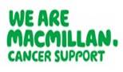

Certificate of Attendance

This is to certify that

Click here to enter name
Attended the following education and training:
Communication Skills Workshop: Facilitating Difficult but Necessary Conversations around Future Care Planning and DNACPR
Date of training: Select date
Training facilitated by: NHSGGC Macmillan Palliative Care Education Team
NHSGGC Macmillan Palliative Care Education Team
Tel: 0141 211 1529 | Email: ggc.carepalliative@nhs.scot | Website: https://rightdecisions.scot.nhs.uk/ggc-palliative-care/

