Quality of Care review for care assurance: data gathering / triangulation

This template can be used to collate the qualitative and quantitative data to support QoC review and any final reports. The QoC guidance and chapters provide detailed guidance on potential quality and safety indicators to be considered once the scope is agreed.
Local context
Examples include:
- NMAHP Strategy/ Framework
  - What are the priorities?
  - What are the key deliverables?
- Care Assurance
  - What is the board care assurance approach?
- Quality improvement
  - What is the board quality improvement approach? (QMS / value management)
Reason for QoC review
Examples include:
- Planned or scheduled
- In response to a trigger (area delivering high quality care or area of concern).
What are you seeking to understand within your system?
Examples include:
- What questions are you seeking to answer?
- What are the enablers?
- What are the barriers?

Key questions
- What are you seeking to understand?
- What questions are you seeking to answer?
- What are the enablers?
- What are the barriers?
Key actions
- Refer to QoC review chapter – Using the elements of the EiC framework.
- Identify quality and safety indicators to inform review.
- Identify consistent timeframe across indicators
Remember to collate information from data, observation and discussion
Example layout using dummy data
Fact finding / data
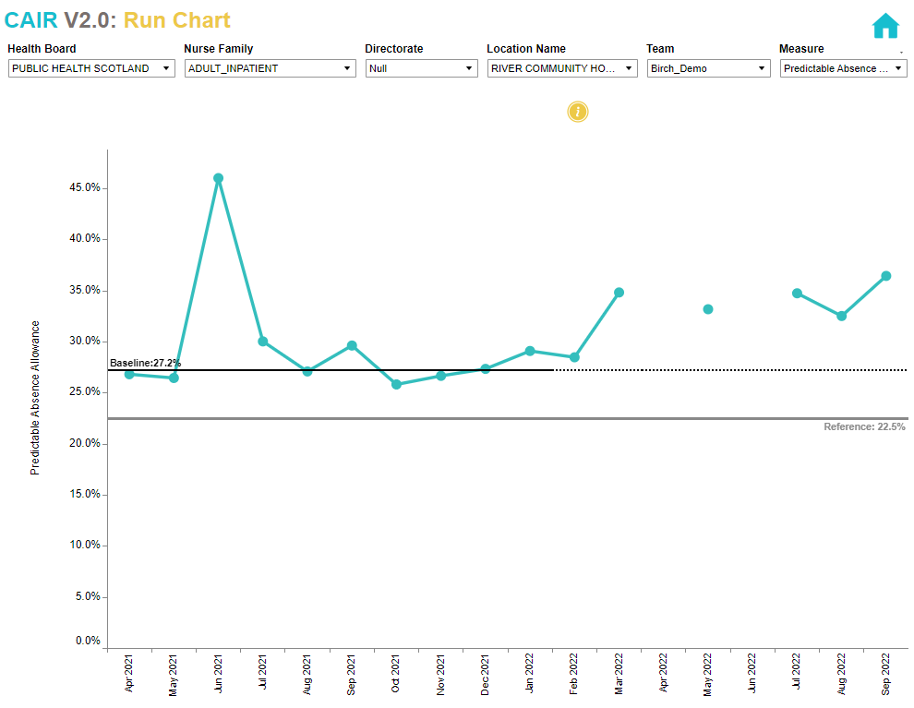
What is your data telling you, what questions are emerging?
Consider the elements on the chart:
- What is it telling you?
- Are there signals in the data that need further explanation?
- What information can you share about the local story?
- Consider value of other QI Tools to understand the system e.g. Pareto Charts, Fishbone (QI Zone Tools on TURAS).

[Element1]
[Desc1]
Fact finding / data
What is your data telling you, what questions are emerging?

[Element2]
[Desc2]
Fact finding / data
What is your data telling you, what questions are emerging?

[Element3]
[Desc3]
Fact finding / data
What is your data telling you, what questions are emerging?

[Element4]
[Desc4]
Fact finding / data
What is your data telling you, what questions are emerging?

[Element5]
[Desc5]
Fact finding / data
What is your data telling you, what questions are emerging?

[Element6]
[Desc6]
Fact finding / data
What is your data telling you, what questions are emerging?

[Element7]
[Desc7]
Fact finding / data
What is your data telling you, what questions are emerging?

[Element8]
[Desc8]
Fact finding / data
What is your data telling you, what questions are emerging?

[Element9]
[Desc9]
Fact finding / data
What is your data telling you, what questions are emerging?

[Element10]
[Desc10]
Fact finding / data
What is your data telling you, what questions are emerging?

[Element11]
[Desc11]
Fact finding / data
What is your data telling you, what questions are emerging?

[Element12]
[Desc12]
Fact finding / data
What is your data telling you, what questions are emerging?

[Element13]
[Desc13]
Fact finding / data
What is your data telling you, what questions are emerging?

[Element14]
[Desc14]
Fact finding / data
What is your data telling you, what questions are emerging?

[Element15]
[Desc15]
Fact finding / data
What is your data telling you, what questions are emerging?

[Element16]
[Desc16]
Fact finding / data
What is your data telling you, what questions are emerging?

