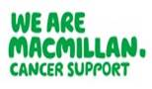

Certificate of Attendance

This is to certify that

Click here to enter name
attended the following education and training:

CAS End of Life Standard 11 Link Nurses Study Day
Date: Click to enter a date
Venue: Click here to enter text
Training facilitated by: NHSGGC Macmillan Palliative Care Education Team
NHSGGC Macmillan Palliative Care Education Team
Tel: 0141 211 1529 | Email: ggc.carepalliative@nhs.scot | Website: https://rightdecisions.scot.nhs.uk/ggc-palliative-care/

