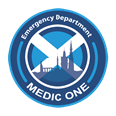

(Date)

Dear

Following your recent attendance to the Royal Infirmary of Edinburgh Emergency Department, your chest CT has been reported by the radiologists as normal and you require no further investigation .

The formal report will be available to your GP but please contact us on 0131 242 5311 if you wish to discuss this further.

Sincerely

