Date:

To:

We have been unable to contact you by telephone and would be grateful if you could contact the Emergency Department at the Royal Infirmary of Edinburgh to discuss the results of the xray you had performed on your recent attendance. Our telephone numbers are below.

Kind regards,

ED consultant

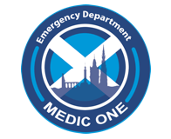
Contact telephone numbers: 0131 242 3511 / 3687 / 1300

