

TRAUMA TEAM LEADER CHECKLIST

Pre Arrival

Confirm appropriate tiered response activated
Allocate roles
Ensure PPE worn by team
Prepare trauma mattress (NOT IF PENETRATING)
Pre-alert CT
Brief team members
- Clarify ability/experience including thoracotomy capability
- Ensure team booked in with Scribe
- Confirm role and priorities on arrival of patient
- Plan for initial resuscitation/investigation
- Reinforce team behaviours
Pelvic binder on trolley
US ready (confirm individual competent to perform)
Digital Clock ready
Draw up 10mg Morphine
Reception ready to book patient in (ALL CODE RED)
Preload CXR Cassette (ALL CODE RED)
Prime Belmont with RCC (ALL CODE RED)
Bair Hugger Under blanket on trolley (All Code Red)
On Arrival

ATMIST Handover
Transfer Patient as per SOP
Aim For CT and/or theatre within 30 minutes
TXA if not given prehospital
IV Cefuroxime 1.5g (& metronidazole if significant contamination) for open fractures
Ensure SAS/EMRS/MEDIC 1 patient record form & Pre alert form completed

TTL NAME:

STAND DOWN CODE RED once appropriate. Return & preserve blood products as able.


South East Scotland Trauma Network
Age
Mechanism
Gender
Time of incident
Date
Injuries Suspected
Requirements
Pre Alert
ED Trauma Documentation

Arrival by:

Road Air
Pre-hospital: SAS
Medic One EMRS SCAA MOD
Coastguard
Standby Received:

Time received:

Affix Label Here

Signs | RR | SpO2 | HR | BP | / | Type of Activation:
 | GCS | BM | Temp |  |  | ED
ETA |  |  |  |  |  | Enhanced Code Red  Time of activation:

SPECIALTY | NAME | GRADE | ARRIVAL TIME | CONSULTANT
Trauma Team Leader
Anaesthetics
ODP
General Surgery
Orthopaedics
Critical care
Vascular

L
Pre Hospital Handover
Time of Arrival:
Time of Incident:
Age & Sex:
Mechanism of Injury:
Injuries Sustained:

Signs & Symptoms:  A –  B –  C –  D –  E – | GCS E V M BP  RR HR SATS
Treatments / Trends:

A – Self NP Guedel LMA RSI CRIC Collar

B – Thoracostomy Thoracotomy O2

C – Fluid Blood Cannula IO TXA Splint

D –

E – Binder Femoral
Drugs Administered
Blood in mls: Fluid in mls: Other:

Other information:

Primary Survey
Assessment Intervention
External haemorrhage SiteY
N
Tourniquet/site
Site
Haemostatics
<C>
A
Clear Compromised
Basic RSI
Surgical Collar NG/OG

B | Air Entry Visible Wound | R R | L L | O2  Thoracostomy
 |  |  |  |  | R | L
 | Tenderness | R | L | Chest Drain | R | L
 | Crepitus  Surgical Emphysema | R  R | L  L | CXR Comments
 | 1st RR
 | 1st SpO2
C
Abdomen Pelvis
Long Bones 1st Cap Refill 1st HR
1st BP
Pelvic Binder Fluids (mls)
Blood (mls)
TXA
PXR Comments
FAST Report (include name of operator)
D
Head Injury
GCS E ….. V…… M……
Pupils R .......... mm Reactive Y/N Priapism
L .......... mm Reactive Y/N
Blood Glucose Urinary catheter
HCG
Limbs Mvt LUL LLL RUL RLL
Urine
E
1st Temp
Bair Hugger Warm Blankets

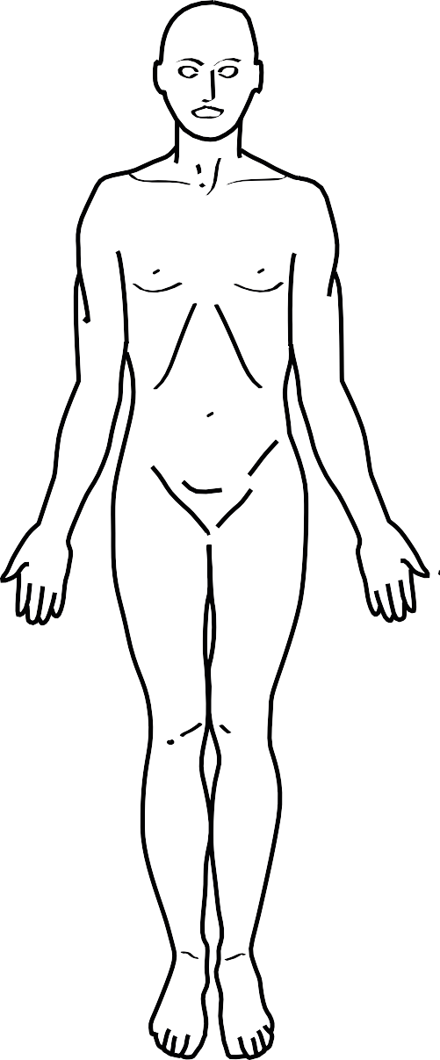
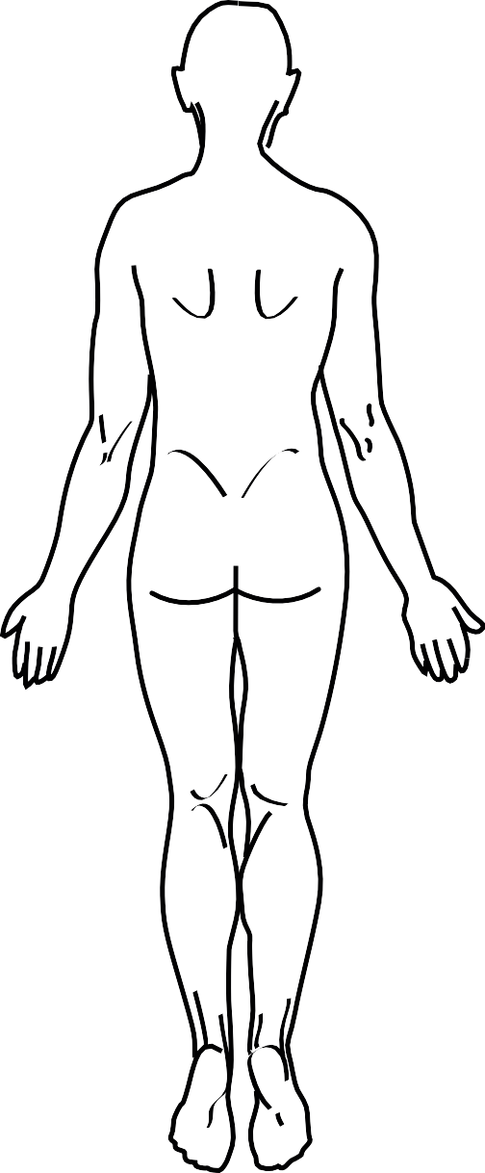
Y
N
Tetanus
Antibiotics
Time
A M P L
E
Secondary Survey

Key
Tenderness/Pain | T
Abrasion | A
Bruising | ////
Fracture | #
Laceration (cm) | +++
Incision | O
GSW | X
Swelling | S

Secondary Survey/Injury Summary

 | Injuries | Investigation Results | Outstanding Tasks
Head
MaxFax/ENT
T / L spine
C Spine/neck
Chest
Abdomen
Pelvis
Upper Limbs
Lower Limbs
Perineum, rectum, vagina.
Skin

In Spinal Injuries please print separate ASIA Chart. In Burns please print separate Burns Chart.

Trauma Time Line

Time | List of Events/Decisions | Signature

Trauma Time Line

Time | List of Events/Decisions | Signature

Invasive Devices Record

Peripheral Venous Catheter |  |  |  |  |  |  |  |  |  |  |  |  |  |  | Peripheral Venous Catheter
Date: Time: |  |  | Operator: |  |  |  |  |  |  |  |  |  |  |  | Date: Time: |  | Operator:
Size (circle): Blue |  |  | Pink Green Brown |  |  |  |  |  |  |  |  | Grey |  |  | Size (circle): Blue |  | Pink Green Brown |  |  |  |  |  |  |  |  | Grey
Site: Right Left Hand ACF Forearm Foot |  |  |  |  |  |  |  |  |  |  |  |  |  |  | Site: Right Left Hand ACF Forearm Foot
Procedure Checklist: |  |  | Difficulties/Complications: |  |  |  |  |  |  |  |  |  |  |  | Procedure Checklist: |  | Difficulties/Complications:
Hand hygiene |  |  |  |  |  |  |  |  |  |  |  |  |  |  | Hand hygiene
CHG skin prep |  |  |  |  |  |  |  |  |  |  |  |  |  |  | CHG skin prep
Aseptic insertion |  |  |  |  |  |  |  |  |  |  |  |  |  |  | Aseptic insertion
Needle free port |  |  |  |  |  |  |  |  |  |  |  |  |  |  | Needle free port
Dressing dated |  |  |  |  |  |  |  |  |  |  |  |  |  |  | Dressing dated
 |  |  | 1 | 2 | 3 | 4 | 5 | 6 | 7 | 8 | 9 | 10 | 11 | 12 |  |  | 1 | 2 | 3 | 4 | 5 | 6 | 7 | 8 | 9 | 10 | 11 | 12
Days in situ |  |  |  |  |  |  |  |  |  |  |  |  |  |  | Days in situ
Site Clean Y/N |  |  |  |  |  |  |  |  |  |  |  |  |  |  | Site Clean Y/N
Still req’d Y/N |  |  |  |  |  |  |  |  |  |  |  |  |  |  | Still req’d Y/N

Invasive Line |  |  |  |  |  |  |  |  |  |  |  |  |  |  | Invasive Line
Line Type (circle): CVC Arterial |  |  |  |  |  |  |  |  |  |  |  |  |  |  | Line Type (circle): CVC Arterial
Date: Time: Operator: |  |  |  |  |  |  |  |  |  |  |  |  |  |  | Date: Time: Operator:
Site: |  |  |  |  |  |  |  |  |  |  |  |  |  |  | Site:
USS: Anatomy check Visualised insertion Not used |  |  |  |  |  |  |  |  |  |  |  |  |  |  | USS: Anatomy check Visualised insertion Not used
Procedure Checklist: Difficulties/Complications |  |  |  |  |  |  |  |  |  |  |  |  |  |  | Procedure Checklist: Difficulties/Complications:
Antiseptic hand scrub |  |  |  |  |  |  |  |  |  |  |  |  |  |  | Antiseptic hand scrub
Gown/gloves/hat/mask |  |  |  |  |  |  |  |  |  |  |  |  |  |  | Gown/gloves/hat/mask
CHG skin prep |  |  |  |  |  |  |  |  |  |  |  |  |  |  | CHG skin prep
Aseptic insertion |  |  |  |  |  |  |  |  |  |  |  |  |  |  | Aseptic insertion
Stitched to secure |  |  |  |  |  |  |  |  |  |  |  |  |  |  | Stitched to secure
Line transduced |  |  |  |  |  |  |  |  |  |  |  |  |  |  | Line transduced
Line saved for TPN |  |  |  |  |  |  |  |  |  |  |  |  |  |  | Line saved for TPN
Operator’s Signature: |  |  |  |  |  |  |  |  |  |  |  |  |  |  | Operator’s Signature:
Post insertion CXR YES |  |  | N/A |  |  | reviewed by: |  |  |  |  |  |  |  |  | Post insertion CXR YES |  |  | N/A |  |  | reviewed by:
Days in situ | 1 |  | 2 | 3 | 4 |  | 5 | 6 | 7 | 8 | 9 | 10 | 11 | 12 | Days in situ | 1 |  | 2 | 3 | 4 |  | 5 | 6 | 7 | 8 | 9 | 10 | 11 | 12
Site Clean Y/N |  |  |  |  |  |  |  |  |  |  |  |  |  |  | Site Clean Y/N
Still req’d Y/N |  |  |  |  |  |  |  |  |  |  |  |  |  |  | Still req’d Y/N

Intubation - Endotracheal
Date: Time: Operator:
Grade of View (circle appropriate): I II III IV
Tube Size: Tube Type:
Distance @ Lip: Distance @ Teeth:
Procedure Checklist: Difficulties/Adjuncts/Complications:
Preoxygenation Cricoid Capnography Auscultation
CXR
Operator’s Signature:
Days in situ | 1 | 2 | 3 | 4 | 5 | 6 | 7 | 8 | 9 | 10 | 11 | 12
Cuff Pressure
Distance @ Lip
Dressing/Tapes

Nasogastric Intubation
Date: Time: Operator:
Size: Type(circle) Standard 7 day Fine bore 31 days Nostril: R / L
Post Procedure Checklist:
Aspirate Yes No pH confirms placement? Yes No CXR required? Yes No
External cables/wires removed pre CXR? Length at Nostril: Aspirate pH:
Bridle
Senior Doctor confirming tube safe to use

Length at nostril - record each day/pm *change to fine bore
1 | 2 | 3 | 4 | 5 | 6 | 7 | 8 | 9 | 10
11 | 12 | 13 | 14 | 15 | 16 | 17 | 18 | 19 | 20
21 | 22 | 23 | 24 | 25 | 26 | 27 | 28 | 29 | 30

Indwelling Urinary Catheter
Date: Time: Operator:
Catheter - Size | 10fg |  | 12fg 14fg
Type: PTFE Silicone |  |  | Male Female Suprapubic
Volume in balloon: Catheter expiry date: 28 days 12 weeks
Procedure Checklist: Difficulties/Complications:
Hand hygiene Aseptic insertion Catheter secured
Lubricant used, expiry date/batch number
Operator’s Signature:
Days in situ |  | 1 | 2 | 3 | 4 | 5 | 6 | 7 | 8 | 9 | 10 | 11 | 12
BD cath care Y/N
Still required Y/N
Drain bag dated

Generic Device Record
Device:
Insertion Date: | Time:
Size:  Insertion details:  Monitoring requirements: | Type:
Operator’s Signature:
Device:
Insertion Date: | Time:
Size:  Insertion details:  Monitoring requirements: | Type:
Operator’s Signature:

