Process for raising a case to book PCEC appointment in Adastra

Version | 3
Date Created | 15/12/2022
Created By | Flow Centre Management Team
Number of Pages | 8
Authorised by

Version control
Date | Author | Version | Reason For Change
07/12/2022 | Jeannie Angelosanto | 1 | Initial Draft
15/12/2022 | Pamela Holland | 2 | Amendments to initial draft
15/12/2022 | Pamela Holland | 3 | Amendments by SLWG during meeting

Patient Triage
Patient assessed by triage team and signposting trigger confirmed or identified. NEWS obtained and patient triaged as safe for re-direction to Lothian Unscheduled Care Service (LUCS) as per NHS Lothian ED signposting policy and LUCS criteria.
SJH clinical staff discuss and agree re-direction to LUCS service with patient and liaise with SJH reception staff to organise LUCS appointment.

Access to Adastra via Launcher
We will no longer use Citrix to access Adastra, but a new Smart Client has been developed into the Adastra Launcher.
This should already be available on your desktop, double click to launch
If this icon is not displayed on your desktop, you can manually download via the Software Centre

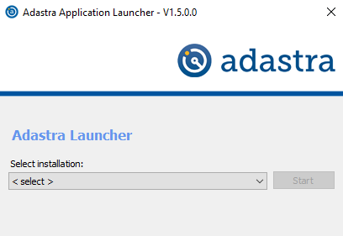
Select Lothian Live from the drop-down menu
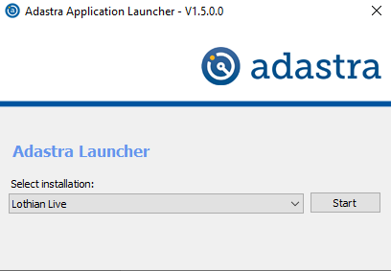
Select Start – the first time you use Adastra on this PC an install will take place then you will be taken to the usual Adastra log in screen where you will be prompted to change your password. Adastra passwords now require a both a capital letter, number and character (@#!$ etc)
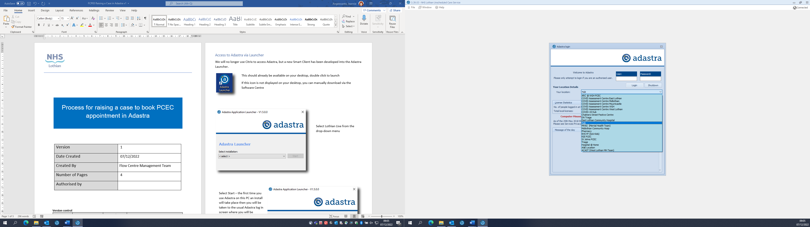
When logging in, ensure you select ‘Hub’ from the Your location dropdown list to enable access to the required area in Adastra

Raising a case to book
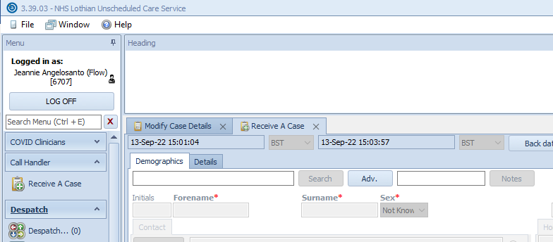
Select Receive a Case form the left-hand menu
Click Adv, to open the Advanced patient search tool

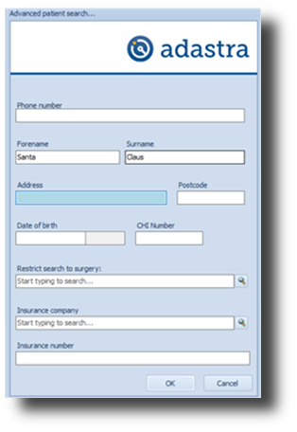
Enter the patient’s date of birth

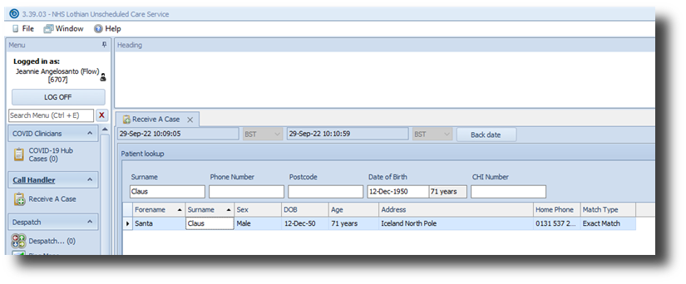
Once you have located the correct patient, double-click to open the case
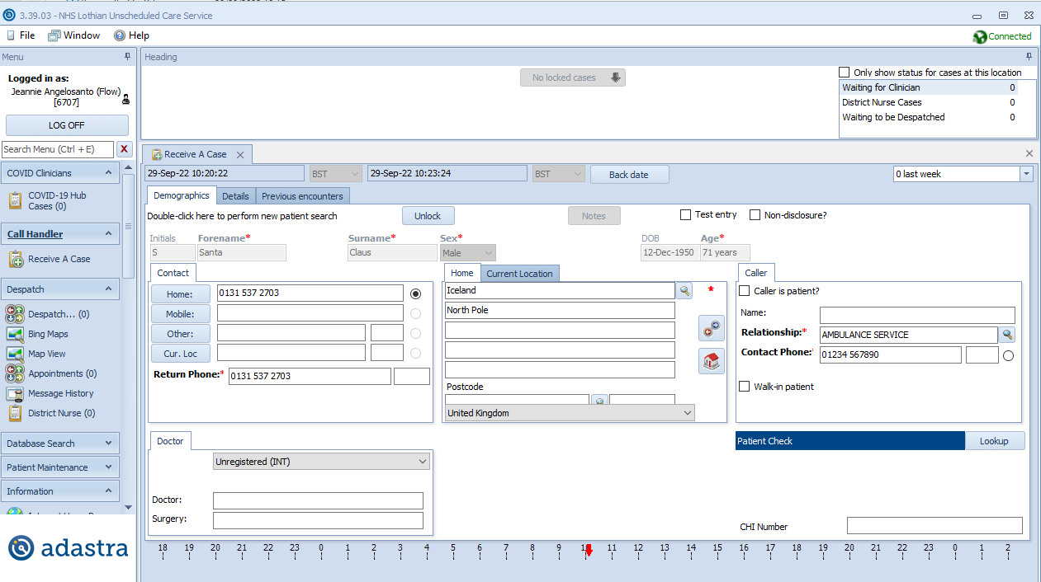
Ensure you run the Patient check before proceeding by clicking Lookup to confirm the CHI number
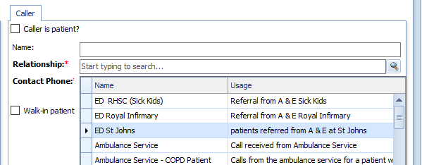
Complete the Caller information, ensuring you enter the most appropriate Relationship for ED referral – i.e., ED St Johns. Include a contact phone number for the referring department in case there are any queries

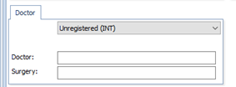
Confirm Doctor information. If a non-Lothian patient, please enter the GP’s details if known. If the patient is not registered with a GP surgery this should be adjusted to Unregistered.

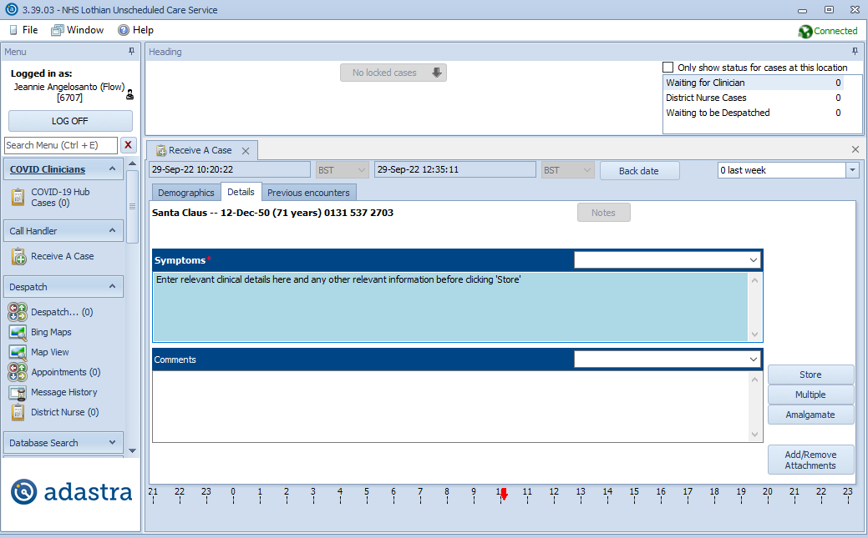
Select the Details tab and enter relevant information in the Symptoms box (please detail presenting complaint, NEWS score, referring doctor and advice provided) before clicking Store
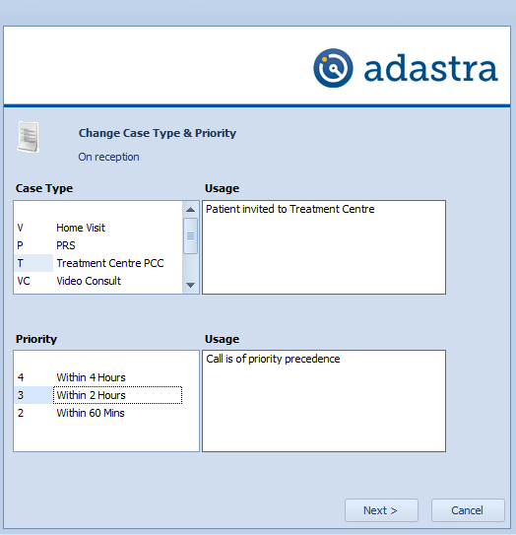
Select Treatment Centre PCC under Case Type and set Priority (2 or 4 hour priority can be selected depending on patient need) before clicking next
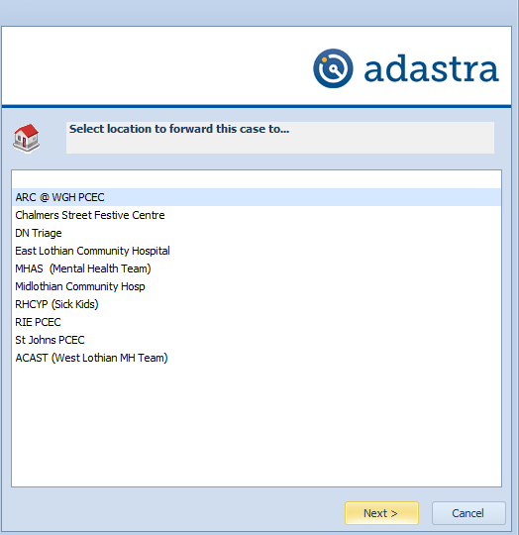

Select the most appropriate site (consider the patient’s home address, clinical presentation and capacity of the clinic) and click next to take you to the Clinic screen where you can continue to book an appointment

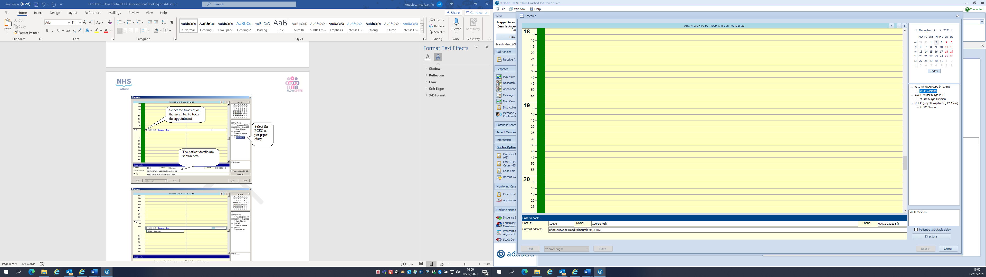
Select the appropriate time slot by clicking on the green bar within the open clinic template
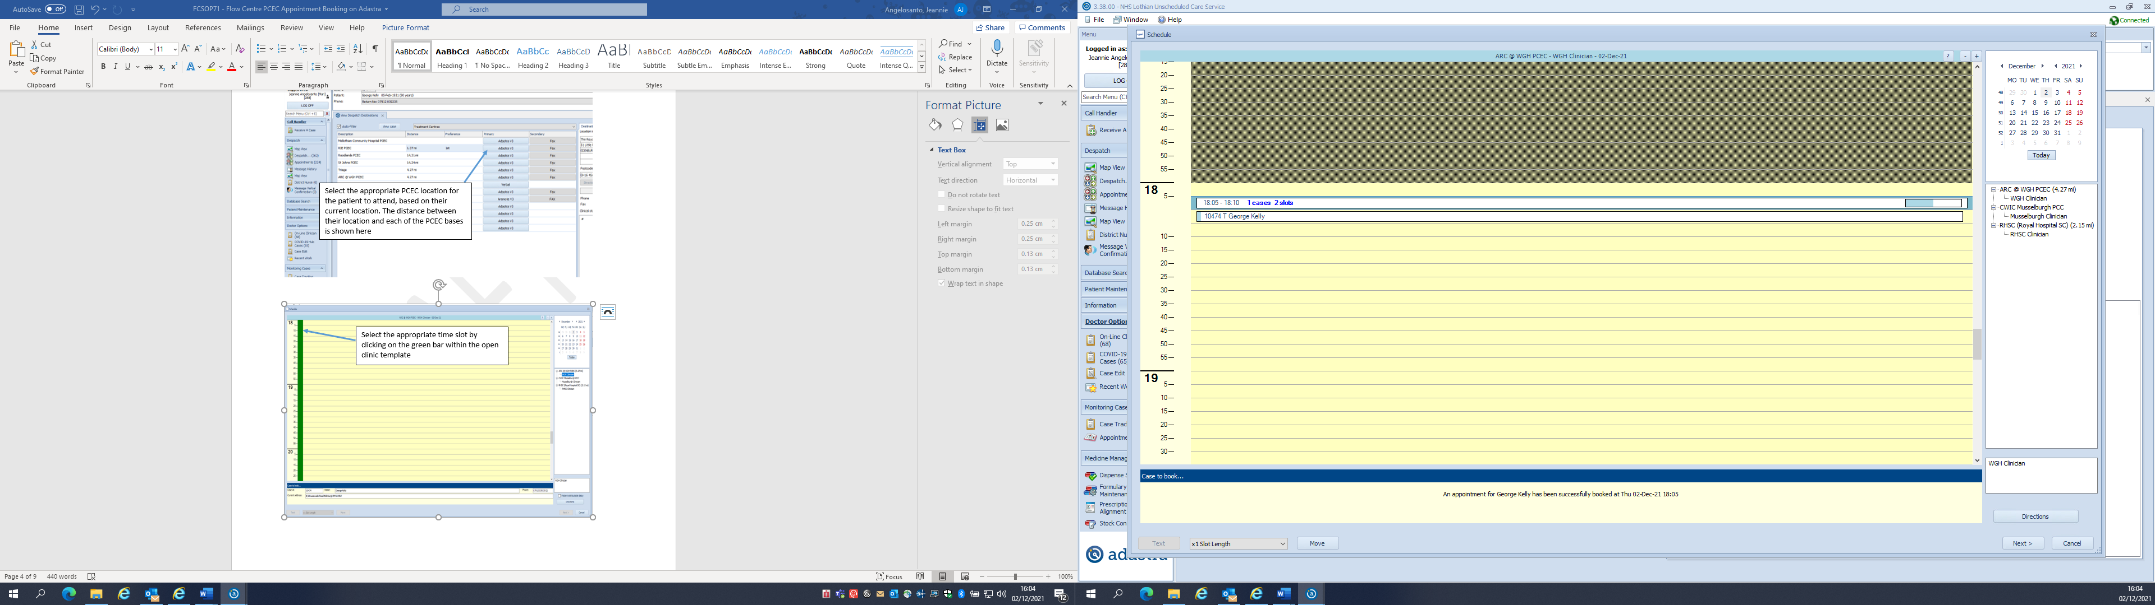
The patient’s details will show in the relevant slot and confirmation will be displayed in the Case to book section at the bottom of the page.
Click Next to complete the case
The appointment is now booked, you can direct the patient to the relevant location for the PCEC clinic

Escalation Process

If there are no LUCS appointments available within agreed 2 or 4 hr time scale at the preferred LUCS location the reception team should consider
- an appointment at an alternative site if possible
- liaise with the referring clinician to identify if patient is appropriate to wait longer for a LUCS appointment
- Remain in ED for ongoing care
In the event that the pilot study is not working the process should revert back to the previous process of LUCS appointments being made via the Flow Centre.

