
Transfer for Thrombectomy
Information for relatives or carers

Page 1/front cover

Please note
The number of pages in an A5 booklet must be a multiple of 4 to print as a booklet.

Printing
The Patient Information Team will provide you with instructions on how to print your A5 booklet when they send you the finalised version.

What is Thrombectomy?
Thrombectomy is a procedure to remove a blood clot from a vessel in the brain which has caused a stroke. Removing the blood clot can help to reduce disability caused by a stroke. A thrombectomy will not be successful for everyone, but has been shown to provide the best chance of a meaningful recovery in some individuals following a stroke. The procedure is usually carried out under general anaesthetic. In some cases, patients transferred for thrombectomy may not get the procedure, as their condition may change during the transfer which makes the procedure unsuitable for them.
Transfer to the Royal Infirmary of Edinburgh (RIE)
The procedure is carried out within the RIE. Unfortunately, relatives/NOK will be unable to accompany the individual in the ambulance to the RIE however a nurse will travel with them. The procedure may take several hours; therefore we do not recommend you travel to the RIE immediately. You may be more comfortable going home and, when the procedure is over, you will be contacted by the Stroke Liaison Nurse from the RIE who will provide you with an update. Following thrombectomy, most patients will be looked after in Ward 130 (which is in the Department of Clinical Neuroscience (DCN) building) for the first 12-24hours.
Please do not be alarmed if you do not hear from the Stroke Liaison Nurse for a number of hours, as the length of time the procedure takes will vary for each individual.

Getting to the RIE
The RIE is located at 51 Little France Crescent, Old Dalkeith Road, Edinburgh, EH16 4SA. Telephone Number 0131 536 1000. There are various car parks within the RIE. The closest car park to DCN Ward 130 is 1B and can be accessed from Gate 1, see map on following page. For public transport, please access your local services for information or the following useful links:

Lothian Buses on 0131 555 6363 or
www.lothianbuses.co.uk
Traveline Scotland on 08712002233 or
www.travelinescotland.com

Page 3
Map of the RIE site
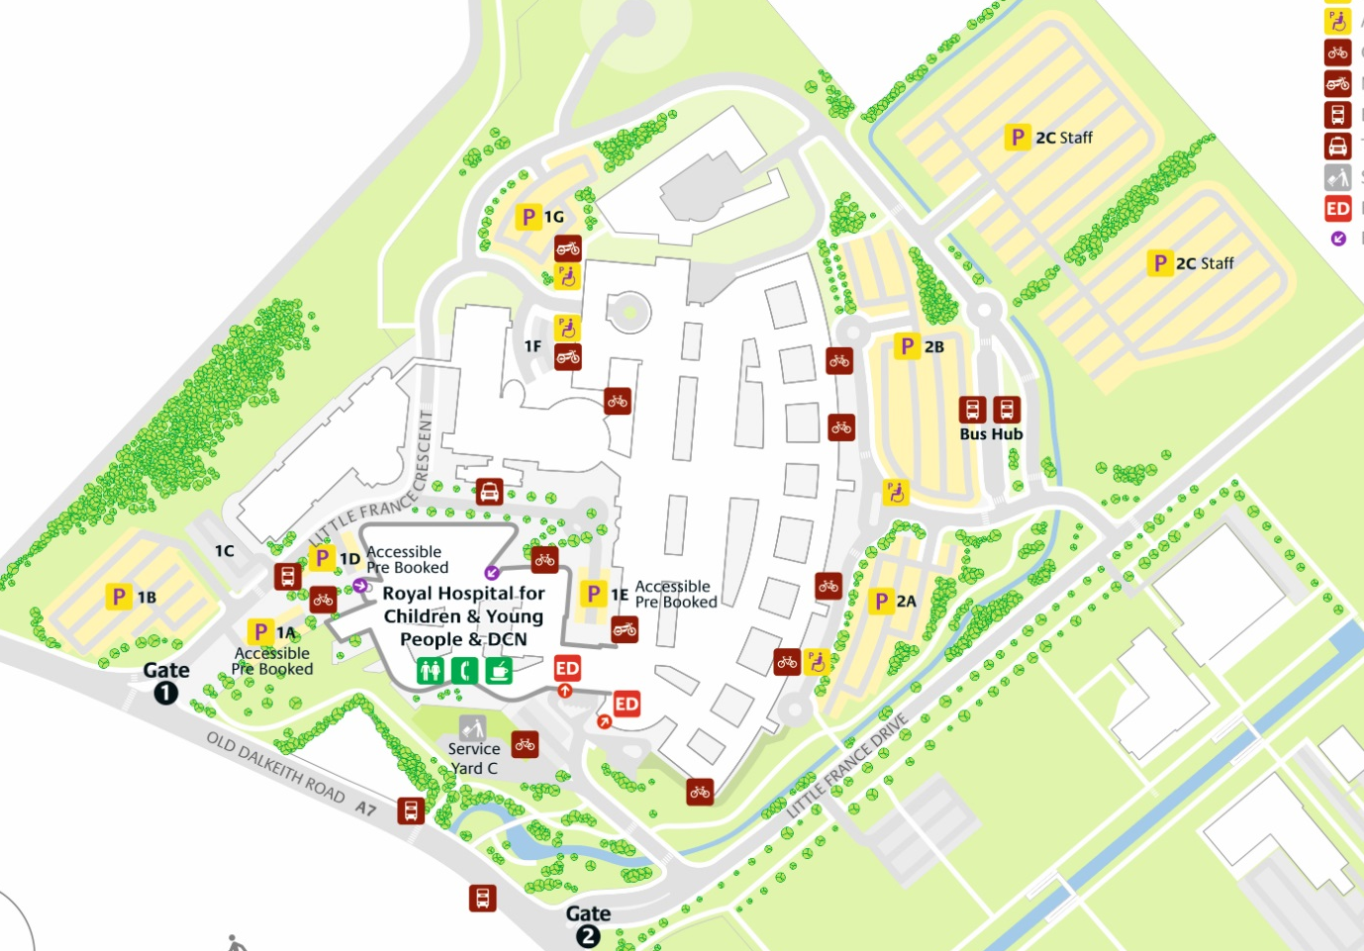
DCN building in red circle

Page 4/last page
Transfer back to St John’s Hospital

This will depend on a variety of factors and will be based on each individual’s own specific needs. Some individuals may be discharged home directly from the RIE and some may need to stay within the RIE for a few days or longer. Other individuals may be transferred back to St John’s Hospital for ongoing care which will often happen the day after the procedure.

