TrakCare : Neurosurgery Referrals
- Making a referral via TrakCare
- This can be done by placing an order for an On call Neurosurgery referral. Short code for Category – On call Referral is ‘OR’

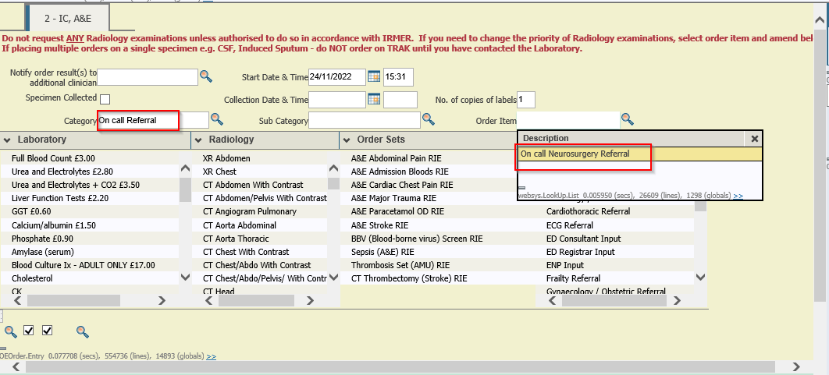

- ‘On call Neurosurgery Referral ’ can be selected from ‘Other Orders’ section also

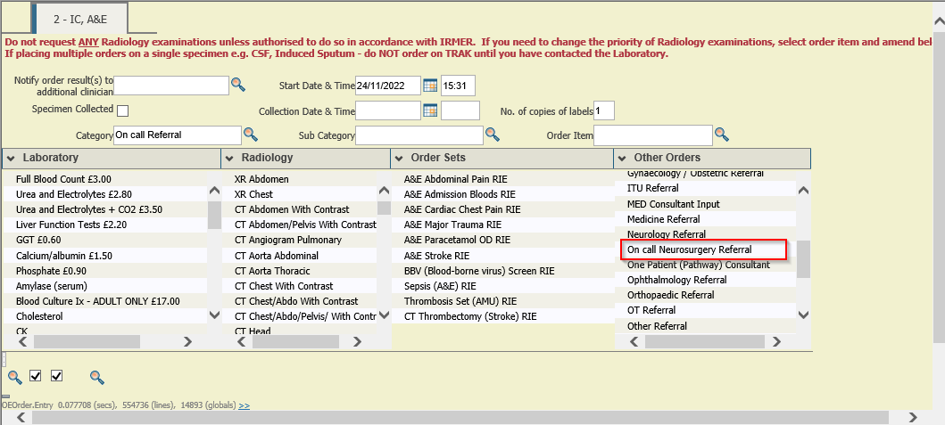

- Click on the questionnaire link – ‘On Call Referral ’

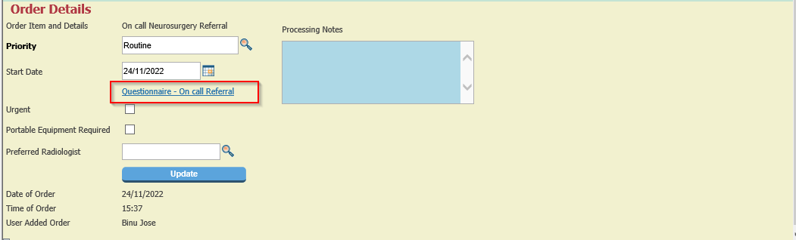

- Referral Questionnaire. All fields in bold must be filled out.

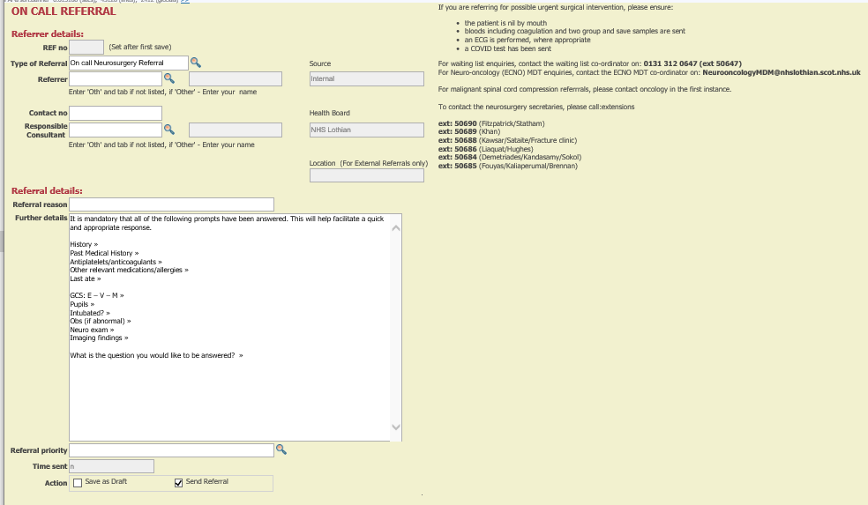

- Once the initial referral has been made it cannot be edited, so please make sure it is correct. If you would like to save the referral and complete it later before you send the referral, please tick ‘Save as Draft’ checkbox

- Once the details are filled, tick ‘Send Referral’ checkbox, password and update the screen.

- Update the ‘Orders Details’ & ‘Alerts’

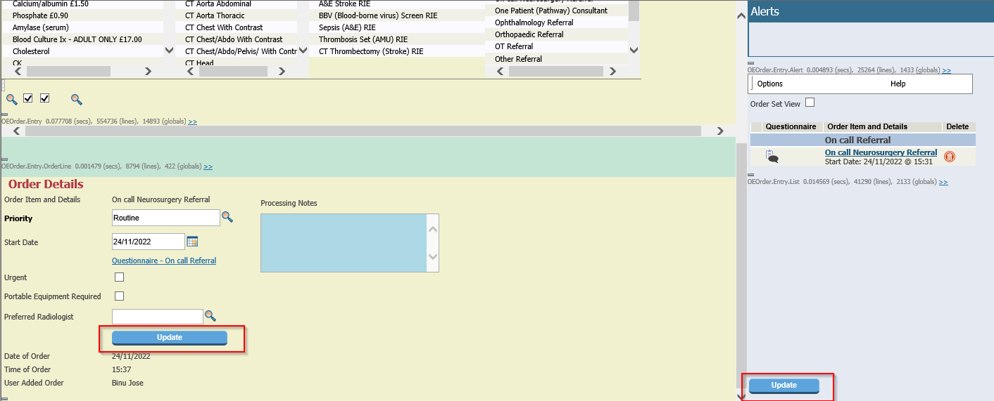

- Answer the order question, click update and then your referral will be added in TRAK. The On call Neurosurgeon will be notified via Teams
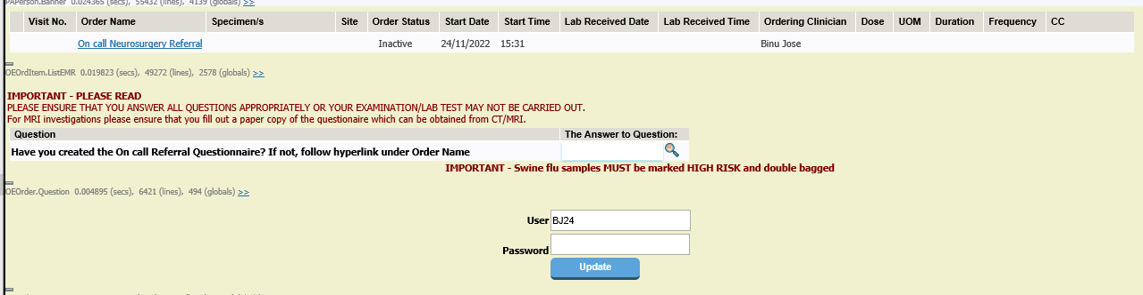

- Icons associated with the referral which has been made for the patient.
The On call Referral questionnaire can be accessed by clicking on these icons.
- Once the referral is made , the document icon will be displayed on the floor plan. | 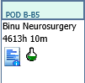
- The neurosurgeon may acknowledge the referral but may decide to respond later. In this case there will be a white envelope with a black border displayed for the patient on the floor plan. | 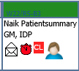
- If the neurosurgeon replies to your referral with a message with high priority, there will be a flashing red envelope displayed for the patient on the floor plan. | 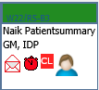
- If the neurosurgeon replies to your referral with a message with low priority, there will be a green envelope displayed for the patient on the floor plan  - The above icons display in Ward floor plan tooltip also (Hover the mouse over the patient name on the floor plan)  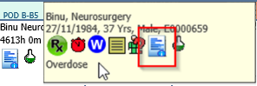 | 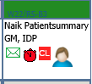
- Accessing the referral questionnaire
  - On clicking any of the referral icons above, the referral questionnaire will open.
  - The questionnaire can also be accessed from EPR->Overview Progress->>Referrals >>On call Referrals
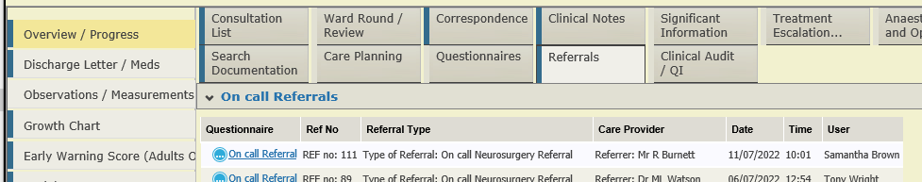
  - To prevent a questionnaire from being locked to another team a message will display if the questionnaire has been open for over 3mins.

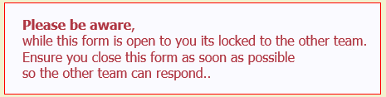

Message then changes after 5 minutes

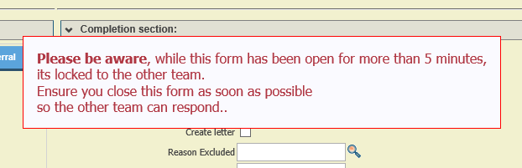

- Updating the referral
  - If you wish to send additional messages in relation to the referral made or reply to the message sent by the Neurosurgery team, then access the questionnaire via the icon on the floor plan.
  - Update the dialog details section. Tick the checkbox for Referring Team and fill in the other details

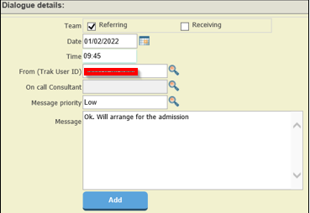

  - Once you click on the ‘Add’ button, your message will get added in the table below. The latest message will be shown at the top

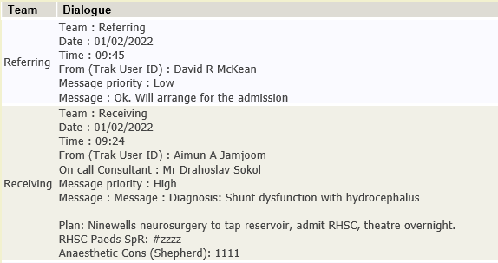

  - If a user forgets to click ‘Add’ after entering dialogue details a warning message will display when they go to Update

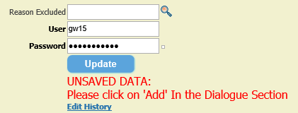

  - If the user enters their password and presses Enter rather than selecting UPDATE a message will display to say they need to select UPDATE. It is vital to enter Password and select update button for the notification message to be sent to the On call Neurosurgery team via MS Teams message.

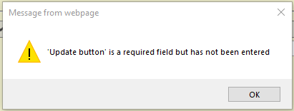

- The Initial referral and subsequent dialog between the referring location and DCN is also added to the Clinical notes and can be viewed via Acute EPR->Clinical Notes

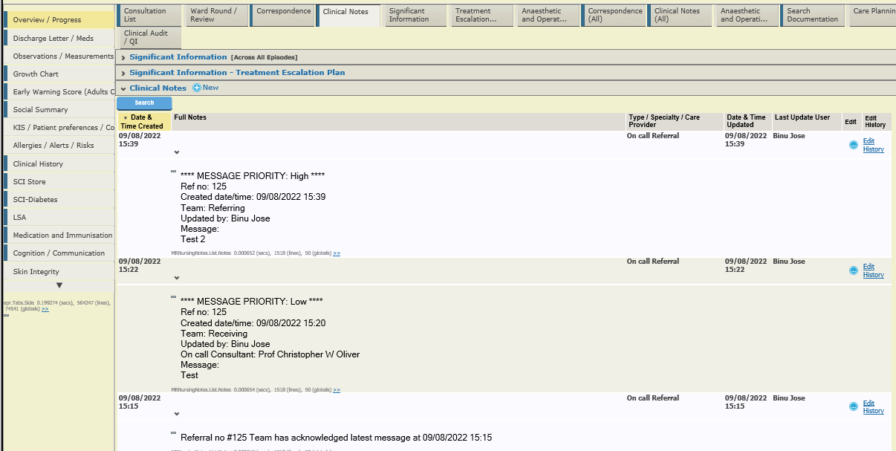
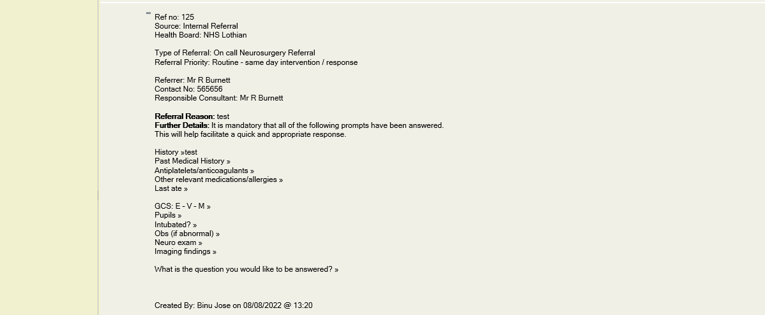

- If the response received from the DCN is complete, you may wish to tick the Dialog complete checkbox. This will take the icons associated with the referral off the floorplan.
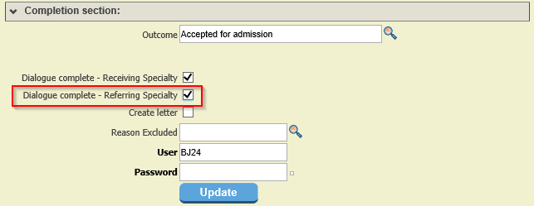

- Users can also create a letter which contains the entire dialog by ticking ‘Create Letter’ checkbox and updating the referral questionnaire

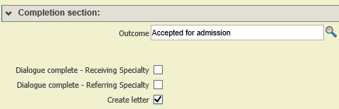

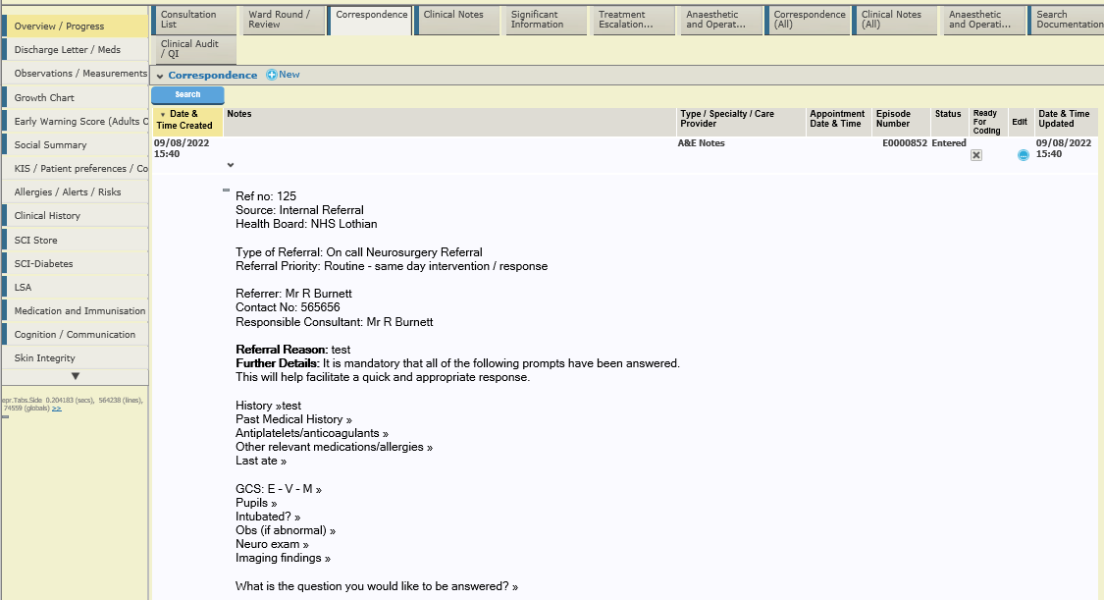
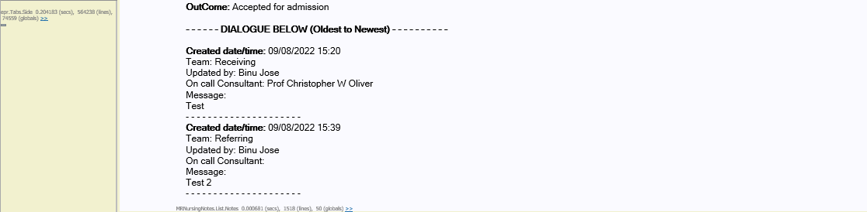

- All referrals made will display on the service request workbench. The work bench can be accessed via – Home ->> WB Menu ->> Service Req WB ->> Options ->> On Call Referral

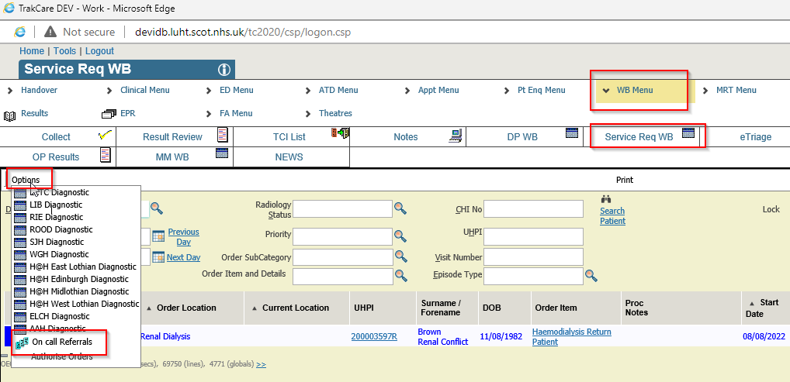

- By default, the workbench will show the list of referrals made in the last 30 days with the most recent referral at the top of the list.

